**MapMyNotes – AI-Powered NLP Study Companion**

**Project Report submitted in the partial fulfilment**

**of**

Bachelor of Technology

In

Computer Engineering

**SVKM’s NMIMS University**

(Deemed-to-be University)



**School of Technology Management and Engineering(STME)   
Indore, Madhya Pradesh  
2025-2026**

**Submitted By: Avni Bhardwaj  
Submitted To: Dr. Raj Gaurav Mishra  
Course:** Natural Language Processing (NLP) **Project Type:** Mini Project – Individual **Submission Date:** 27th October 2025

**Abstract**

The project **“MapMyNotes – AI-Powered NLP Study Companion”** is an intelligent learning application that automatically converts raw text, PDFs, or PowerPoint slides into **interactive mind maps**, **AI-generated explanations**, and **smart revision tools** such as **flashcards and quizzes**.  
Using **Natural Language Processing (NLP)** concepts and the **Google Gemini Generative AI API**, the system extracts key topics, identifies hierarchical relationships, and summarizes knowledge for better understanding and retention.

The goal of MapMyNotes is to assist students, educators, and professionals in converting unstructured study material into **visually organized, semantically meaningful, and easy-to-revise formats**.

**Problem Statement**

In today’s academic environment, students often deal with vast quantities of unstructured digital notes, PDFs, and presentations.  
Manual summarization and concept mapping are time-consuming and error-prone. Students lack tools that can:

* Automatically **understand and structure** educational content,
* Provide **visual summaries** for quick learning, and
* **Test comprehension** interactively through quizzes and flashcards.

Hence, there is a need for an **NLP-driven intelligent system** that can perform **content understanding, hierarchy extraction, and automatic concept visualization**.

**Objectives**

1. To design a **Streamlit-based NLP application** that converts text, PDFs, and slides into structured **mind maps**.
2. To use **Google Gemini API** for semantic topic extraction, summarization, and question generation.
3. To implement **hover-based AI explanations** for each topic node using natural language.
4. To generate **flashcards and quizzes** automatically for student self-assessment.
5. To visualize hierarchical data dynamically using **D3.js** for interactive exploration.

**Tools, Libraries, and Technologies Used**

| **Category** | **Library / API / Tool** | **Purpose** |
| --- | --- | --- |
| **Frontend Framework** | Streamlit | Web interface and layout rendering |
| **Visualization** | D3.js (via HTML integration) | Dynamic hierarchical mind map visualization |
| **Backend Language** | Python 3.12 | Core logic, data flow, and NLP integration |
| **Generative AI API** | Google Gemini 2.5 Flash | Text summarization, structure extraction, and quiz generation |
| **Document Parsing** | PyMuPDF (fitz), python-pptx | Extracting text from PDFs and PowerPoint slides |
| **Environment Management** | python-dotenv | Securely handling API keys |
| **File Export Utility** | save-svg-as-png (JS) | Allow users to download mind map as PNG |
| **Data Representation** | JSON | Node-edge hierarchical graph structure |
| **Libraries (Support)** | uuid, json, re, collections.Counter | Unique IDs, parsing, and frequency analysis |

**Methodology and System Flow**

**Step 1 – Input Extraction**

* The user uploads a **PDF**, **PPTX**, or pastes **raw text**.
* The file is processed using:
  + extract_from_pdf() from modules/extract_text.py (PyMuPDF)
  + extract_from_pptx() for PowerPoint text
  + Direct text area input for plain text

**Step 2 – NLP Processing Pipeline**

Executed via process_text_to_mindmap() in modules/pipeline.py

1. **Text Chunking & Summarization:**
   * Long text (>18,000 characters) is split into smaller chunks.
   * Each chunk is summarized using **Gemini** to maintain context.
2. **Topic Extraction & Hierarchical Structuring:**
   * Gemini is prompted with a structured JSON schema to extract topics and subtopics.
   * The model identifies **semantic hierarchies** (main topics → subtopics → sub-subtopics).
3. **Graph Conversion:**
   * The extracted JSON hierarchy is recursively converted into a flat graph (nodes + edges) using build_graph_from_hierarchy().
4. **AI Explanations:**
   * Each node is enriched with a **layman-friendly explanation** and a **technical summary** using explain_node_in_layman() from hover_tooltip.py.
5. **Quiz & Flashcard Generation:**
   * Using the MAP_SUMMARY_PROMPT, Gemini creates a study summary and question-answer pairs in JSON format.
6. **Keyword Extraction:**
   * The system identifies the most frequent and relevant keywords to aid indexing and semantic linking.

**Step 3 – Visualization Layer**

* Implemented in modules/visualize.py using **D3.js**.
* Features include:
  + Dynamic **zoom** and **pan** controls
  + **Pastel-colored nodes** based on hierarchy depth
  + **Hover tooltips** showing Gemini explanations
  + **Download as PNG** feature for map export

**Step 4 – Smart Study Companion**

* Implemented in the **right panel** of app.py.
* Features:
  + **Auto-generated flashcards** from the Gemini summary.
  + **Quick quizzes** with score validation.
  + **Regenerate button** to fetch new quiz sets dynamically.

**System Architecture Flow**

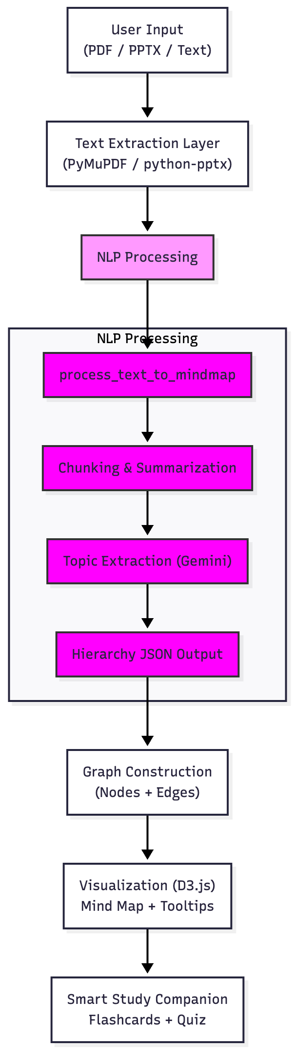

**Use Case**

**Scenario:**

A student uploads a 20-page PDF of “Artificial Intelligence Fundamentals”.

**System Output:**

1. **AI-generated Mind Map**
   * Displays “Artificial Intelligence” as the root topic with branches for **Machine Learning**, **NLP**, **Robotics**, and **Computer Vision**.
2. **AI Tooltips**
   * Hovering over “NLP” shows:

“In simple terms, NLP helps computers understand human language. Technically, it uses tokenization, vectorization, and deep learning models to interpret semantics.”

1. **Flashcards**
   * Q: “What is the purpose of NLP?”  
     A: “To enable machines to understand and process human language.”
2. **Quiz**
   * Auto-generated 5-question quiz for active recall.

**Results and Observations**

* **Accuracy:** Gemini reliably extracts topic hierarchies with logical semantic grouping.
* **User Engagement:** Interactive visualization enhances understanding and memory retention.
* **Efficiency:** The entire map and quiz generation process takes less than 30 seconds.
* **Educational Utility:** Acts as a visual knowledge companion for quick revisions.

**Future Scope**

1. **Domain-Aware Learning:**
   * Adaptive difficulty and tone based on academic discipline.
2. **Multi-Document Mapping:**
   * Merge multiple documents into cross-linked knowledge graphs.
3. **Semantic Search:**
   * Integrate Sentence-BERT embeddings for concept-level search.
4. **Voice Interaction:**
   * Add speech-to-text for note input and TTS for AI explanations.
5. **Cloud Sync:**
   * Integrate Google Drive / Firebase for storing mind maps.
6. **AI Tutor Mode:**
   * Convert quizzes and flashcards into a conversational chatbot tutor.
7. **Study Analytics:**
   * Track user learning progress and recommend weak topic revisions.

**Conclusion**

**MapMyNotes** effectively demonstrates how **Natural Language Processing and Generative AI** can transform traditional note-taking into **intelligent, interactive learning experiences**.  
The system automatically converts study content into a **hierarchically organized visual map**, with **AI explanations, smart quizzes, and flashcards**, enhancing comprehension and retention.

It combines multiple NLP concepts — **summarization, semantic analysis, paraphrasing, keyword extraction, and question generation** — in a single cohesive workflow, proving the practical potential of modern NLP in **education and self-learning systems**.

**References**

1. Google Gemini API Documentation (2025)
2. Streamlit Documentation – https://streamlit.io
3. PyMuPDF Library – https://pymupdf.readthedocs.io
4. D3.js Visualization Library – <https://d3js.org>
5. “Natural Language Processing with Python” – Steven Bird et al., O’Reilly Media

**Appendix – Project Snapshot**

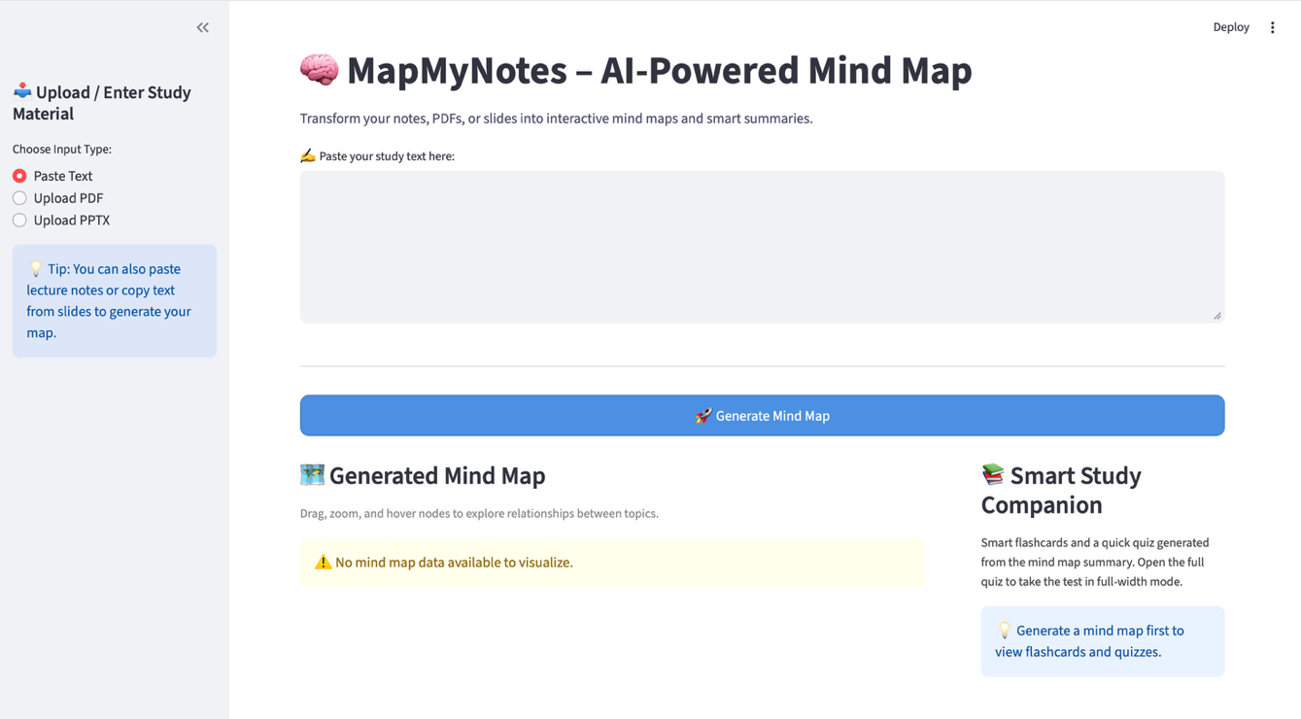

Figure :The main user interface of MapMyNotes, built using Streamlit — where users can upload their notes (PDF, PPTX, or text), view the interactive mind map, and access AI-powered study tools.

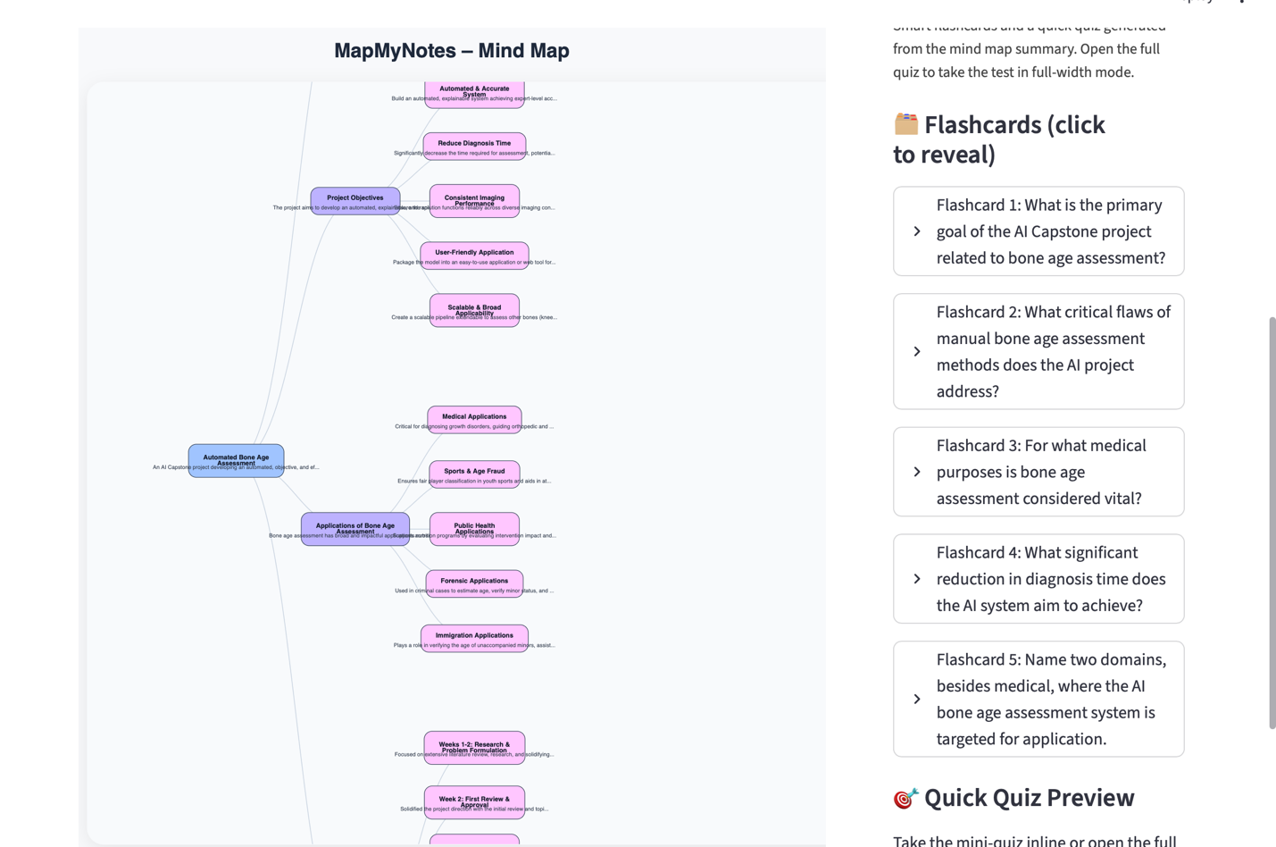

Figure :After uploading a document, the system automatically generates an interactive AI-driven mind map visualizing hierarchical topics and subtopics.

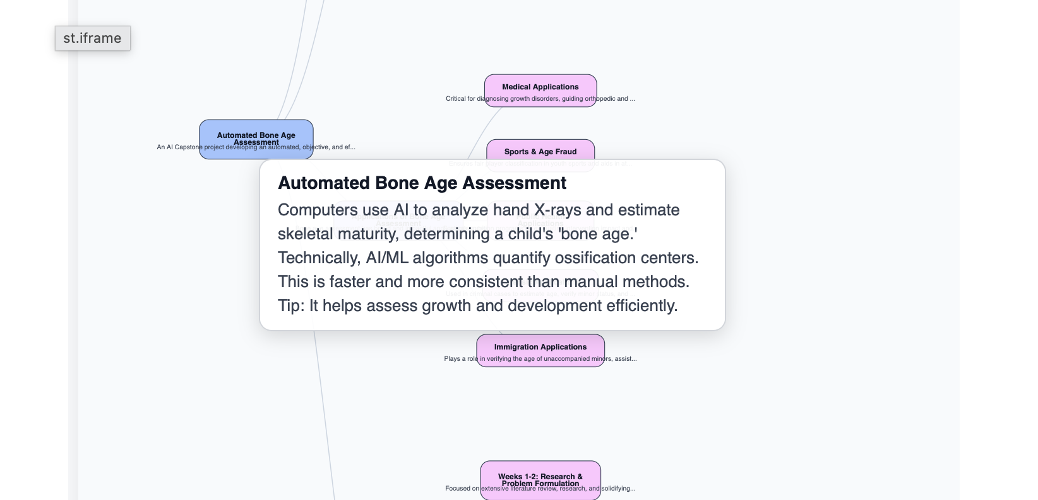

Figure : When hovering over a specific node in the mind map, MapMyNotes displays a layman-friendly yet technically accurate explanation, helping learners quickly understand each topic’s meaning and context.

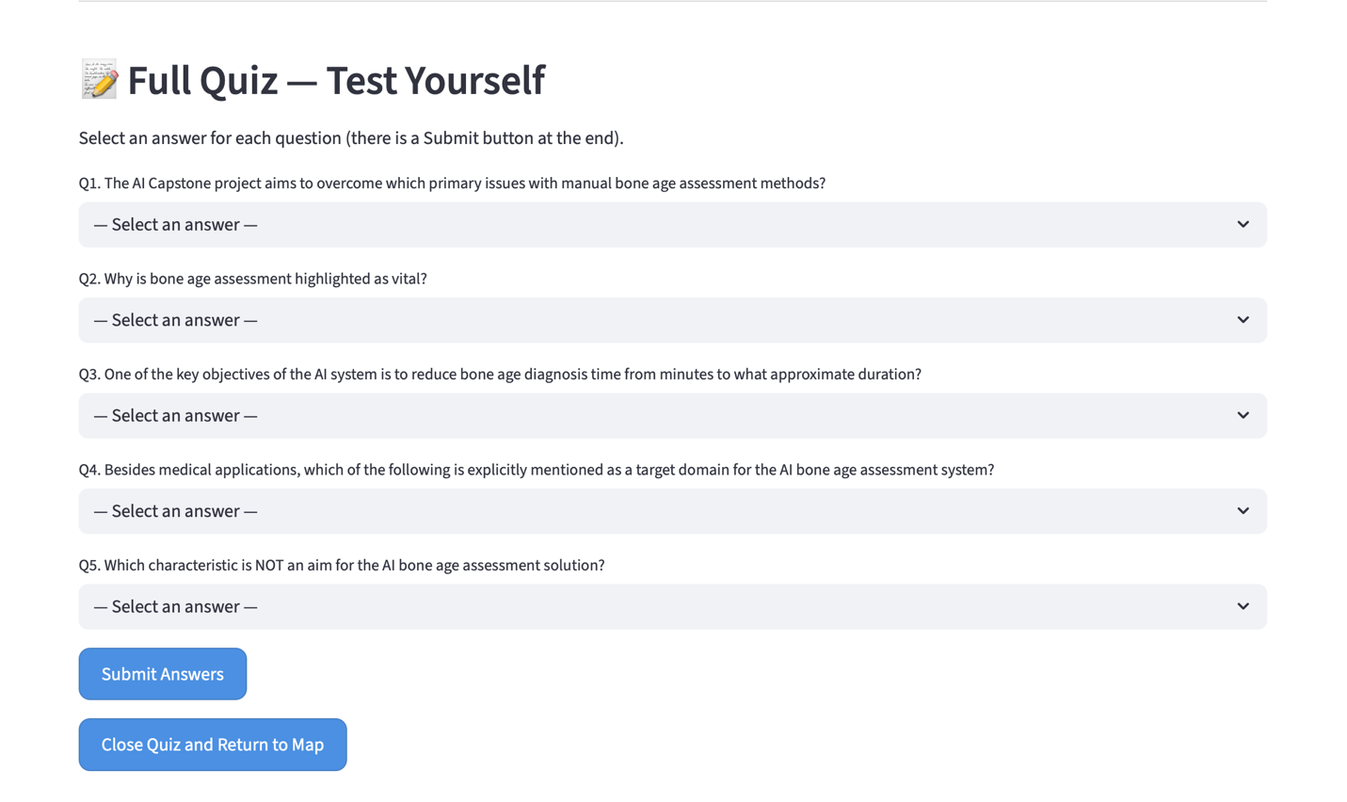

Figure : The interactive quiz module, placed below the visualization, allows users to test their understanding of the generated content. It includes multiple-choice questions, automatic score calculation, and the ability to regenerate or reset the quiz.